PSYC1071: Introduction to Psychology 1

Animal Learning and Cognition

Lecture 2:

Skinner and Pavlov

Professor Anthony McGregor



Historical Background

✦ Charles Darwin (1809-1882)

✦ Edward Thorndike (1874-1949)

✦ John B Watson (1878-1958)

✦ Burrhus Frederick (BF) Skinner (1904-1990)

✦ Ivan P Pavlov (1849-1936)

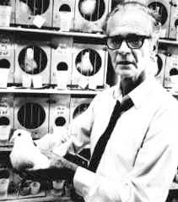 | "The major problems of the world today can be solved only if we improve our understanding of human behavior" About  Behaviorism (1974)  Burrhus Frederick Skinner 1904 - 1990

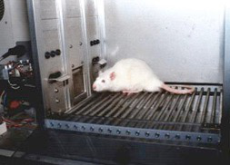

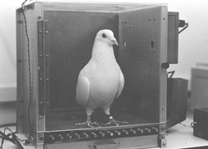


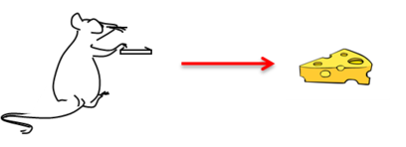
Historical Background Instrumental conditioning
(Operant)
(Stimulus)
Response Outcome
(reinforcer)

•Operant or Instrumental conditioning

• Response shaping

• Schedules of reinforcement

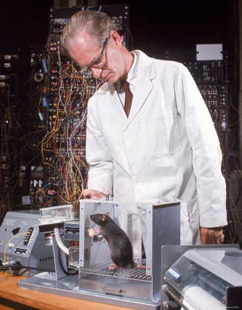



Historical Background Instrumental conditioning
(Operant)
(Stimulus)
Response Outcome
(reinforcer)

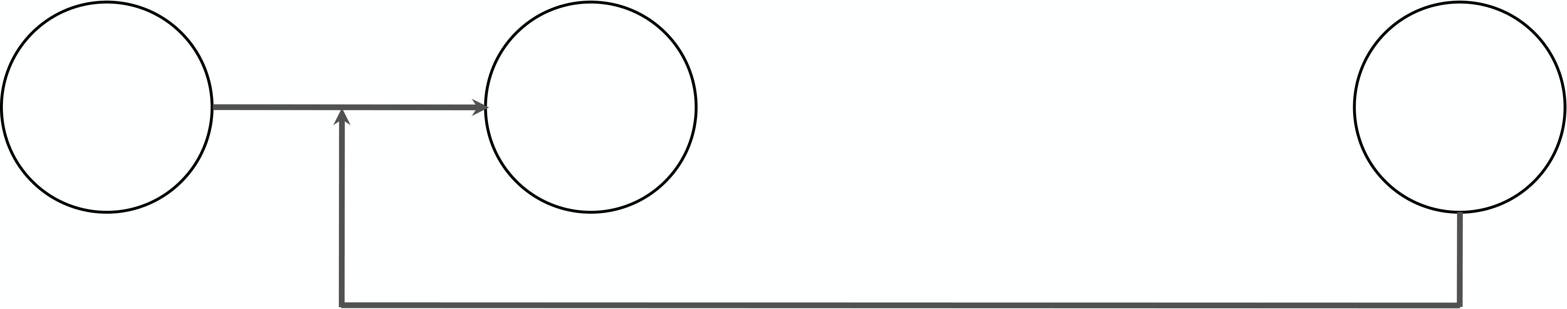
Thorndike’s Law of Effect
S | R | O
+/-
If a response leads to a satisfying outcome
it will be strengthened
The outcome (O) only strengthens or weakens the connection between S and R, and the outcome itself is not
represented in animals on making the instrumental response.

Do animals only learn about a response?

Colwill and Rescorla (1985)





Do animals only learn about a response?
Colwill and Rescorla (1985)
Stage 1 | Stage 2 | Test

Lever press Food | Food Illness | Lever

and | and | and
Chain pull sucrose | Sucrose nothing | Chain


Thorndike’s Law of Effect
S | R | O
+/-
If a response leads to a satisfying outcome
it will be strengthened
The outcome (O) only strengthens or weakens the connection between S and R, and the outcome itself is not
represented in animals on making the instrumental response.





Do animals only learn about a response?
Colwill and Rescorla (1985)
Stage 1 | Stage 2 | Test

Lever press Food | Food Illness | Lever

and | and | and
Chain pull sucrose | Sucrose nothing | Chain

Do animals only learn about a response?

Colwill and Rescorla (1985)

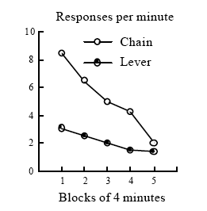

•Operant or Instrumental conditioning

• Response shaping

• Schedules of reinforcement

Cumulative Record for a Fixed Interval (FI) Schedule
Total Responses Since Start of Session | 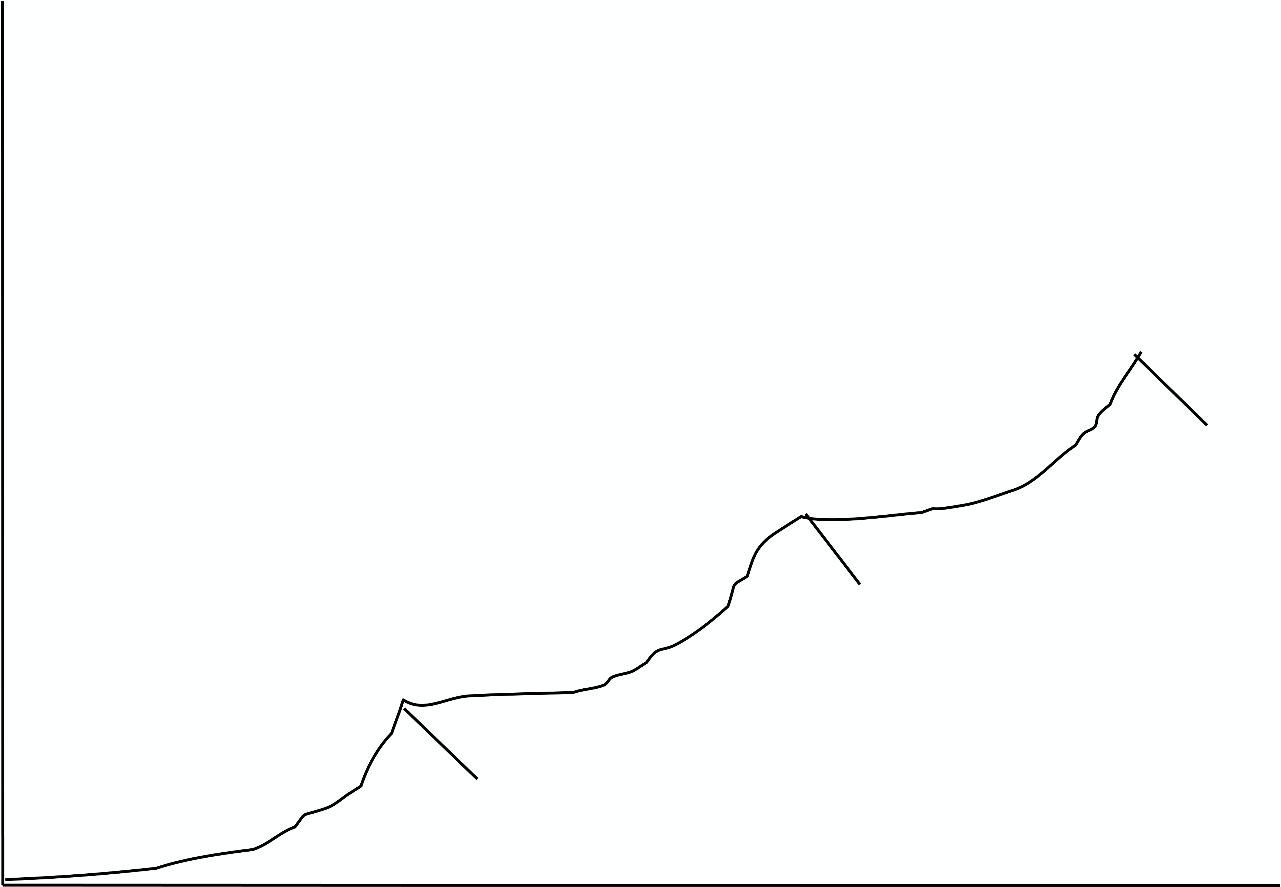
 | 30 | 60 | 90
Time (sec)

Fixed  Variable | Schedules of reinforcement
 | Ratio | Interval | 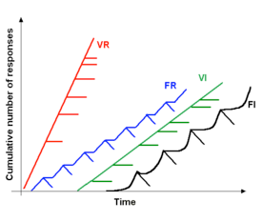
FR | FI
VR | VI

Fixed  Variable | Schedules of reinforcement
 | Ratio | Interval | 
FR | FI
VR | VI

Schedules of reinforcement
FI - studying for exams  FR - ‘piece work’ in factories (gig ecomony?)  VI - instagram  VR - gambling | 

Historical Background

✦ Charles Darwin (1809-1882)

✦ Edward Thorndike (1874-1949)

✦ John B Watson (1878-1958)

✦ Burrhus Frederick (BF) Skinner (1904-1990)

✦ Ivan P Pavlov (1849-1936)

Pavlovian or Classical conditioning

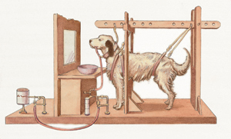

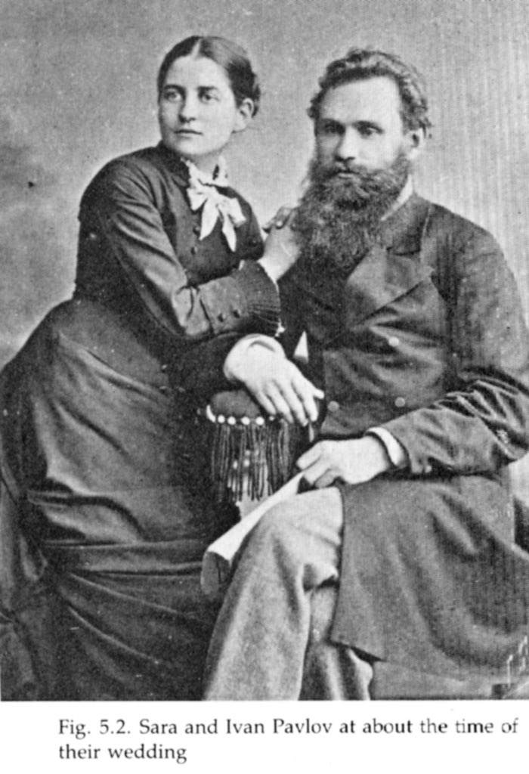

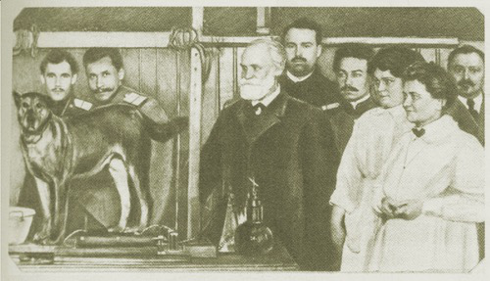

Pavlovian conditioning
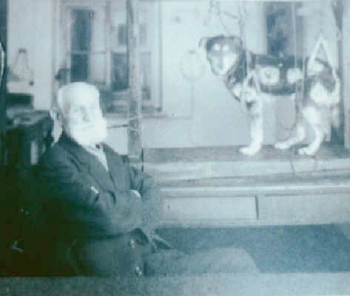 | 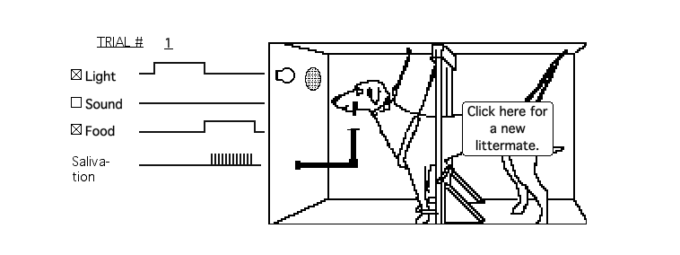 | CS |  | US
 |  |  |  | 
 |  |  |  | UR
CS = conditioned stimulus (light)
US = unconditioned stimulus (food)
UR = unconditioned response (salivation) CR = conditioned response (salivation)

Pavlovian conditioning
 |  | CS |  | US
 |  |  |  | 
 |  |  |  | UR

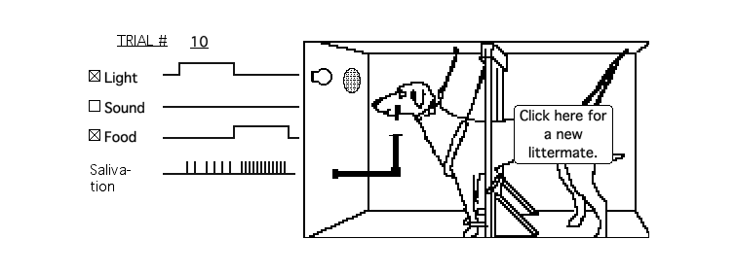 | CS |  | US
 |  |  | 
 | CR
 |  |  | UR
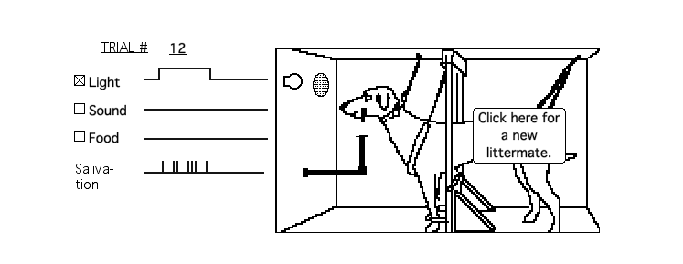 | CS
 | 
 | CR

Historical Background
Instrumental conditioning | Pavlovian conditioning

(Operant)   | (Classical)  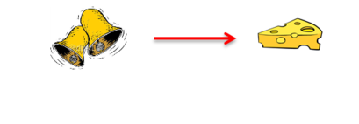

Response | Outcome | Stimulus | Stimulus
 | (reinforcer) | (CS) | (US)

Before conditioning
Bell |  | No Response
Food |  | Salivation
(unconditioned stimulus, US) (unconditioned response, UR)

During conditioning
Bell |  | Food
(unconditioned stimulus, US)
Bell |  | Salivation
(conditioned stimulus, CS) |  | (conditioned response, CR)

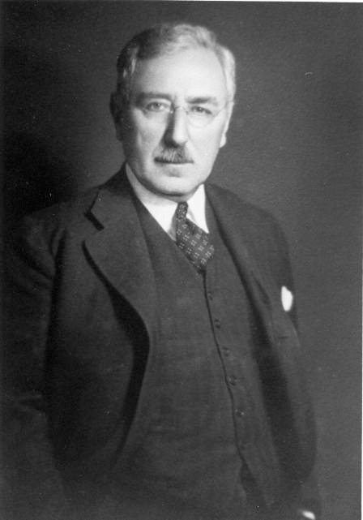 | Edwin B. Twitmyer | 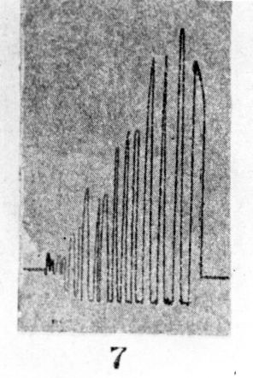
 | 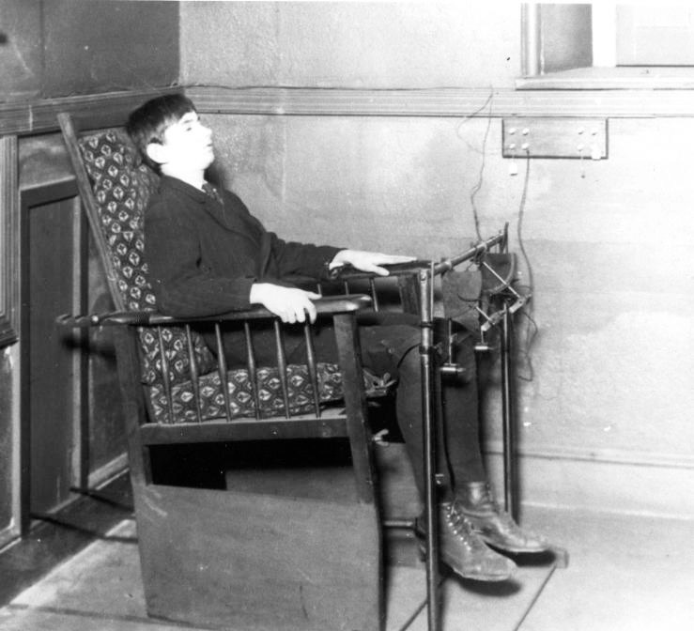

Drops of Saliva | Asymptote
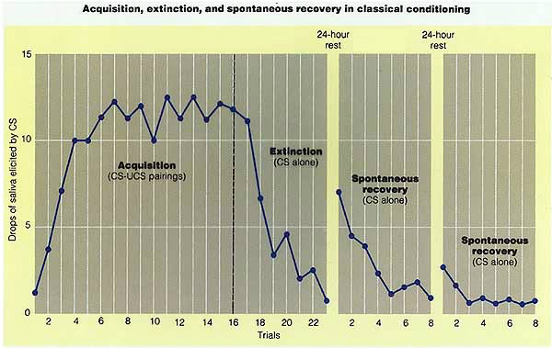
Acquisition | Extinction | Spontaneous
 |  | Recovery
CS-US pairings | CS alone
CS alone

Drops of Saliva | Asymptote

Acquisition | Extinction | Spontaneous
 |  | Recovery
CS-US pairings | CS alone
CS alone

Drops of Saliva | Asymptote

Acquisition | Extinction | Spontaneous Recovery

CS-US pairings | CS alone | CS alone

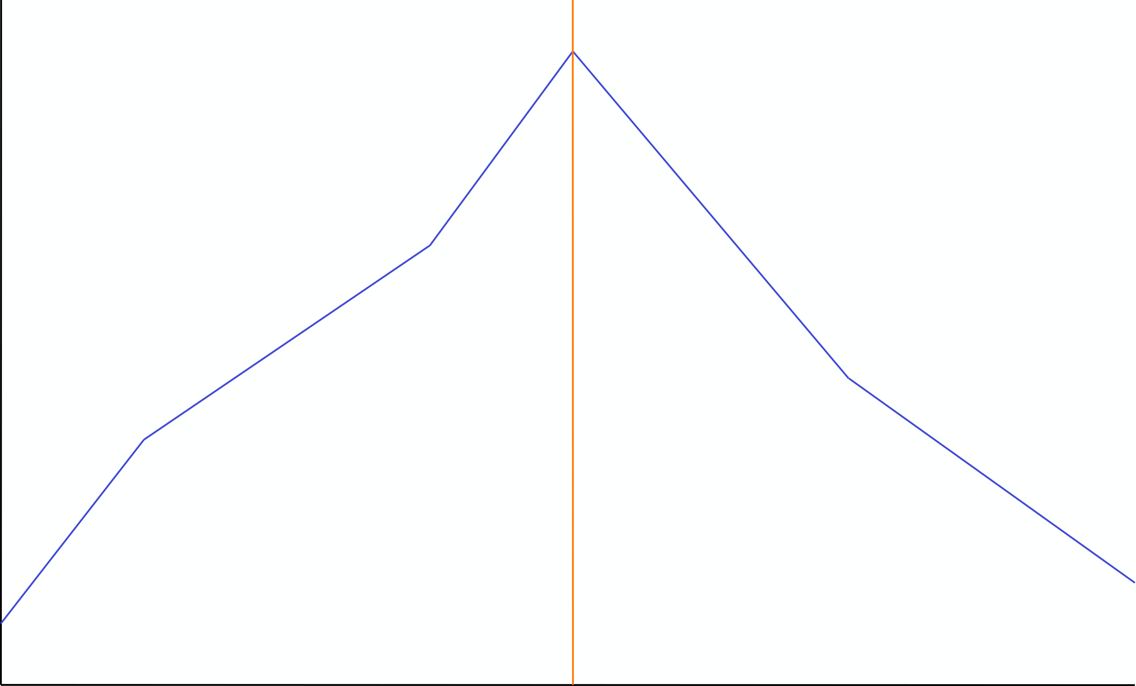
Stimulus generalisation
Generalisation gradient
Generalisation decrement
Drops of Saliva
400 | 800 | 1200 | 1600 | 2000
Frequency Hz

Rachman, S J (1966) Psychological Record, 16, 293-296



Before conditioning
Leather Boot No Response
Picture
??

(unconditioned stimulus, US)

(unconditioned response, UR)

During conditioning
Leather Boot
Picture
(unconditioned stimulus, US)
Leather Boot
??

(conditioned stimulus, CS)

(conditioned response, CR)


Stimulus generalisation
Generalisation gradient
Generalisation decrement
Strength of response! | Slipper | Ankle boot | Knee high boot | High heel | Sandal
Footware

Historical Background

✦ Charles Darwin (1809-1882)

✦ Edward Thorndike (1874-1949)

✦ John B Watson (1878-1958)

✦ Burrhus Frederick (BF) Skinner (1904-1990)

✦ Ivan P Pavlov (1849-1936)

Next lecture - the study of animal intelligence

